Low Level Design

- Association:
  - Association is a relationship between two classes/objects where they are connected or interact with each other.

- Different types of association:
  - One to One Association.
  - One to Many associations.
  - Many to Many associations.

NOTE:
Aggregation and Composition are specialized forms of Association with different ownership strengths.

One to one Association

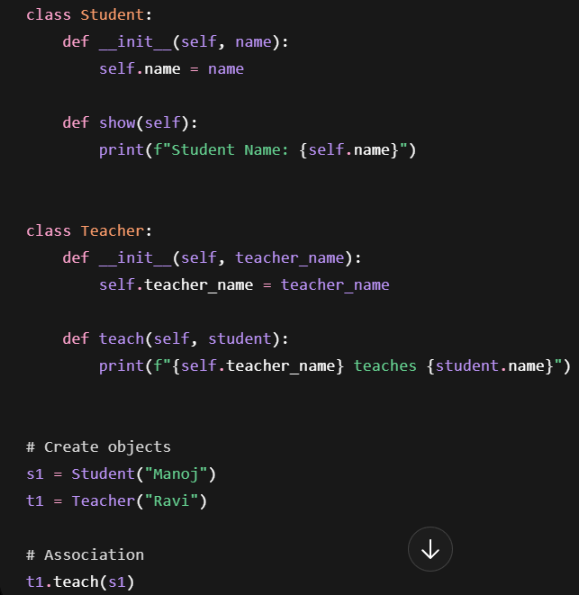

- From above example
  - Teacher object is associated with Student object.
  - But neither owns the other permanently. Both objects are independent.

- UML Diagram:

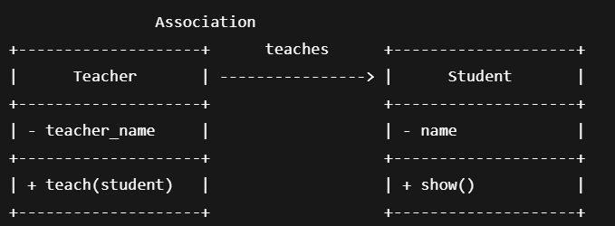

One to Many Association

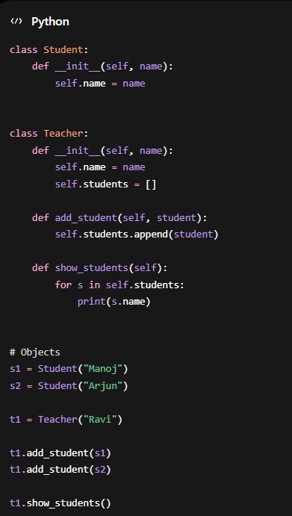

- From above example
  - Teacher object is associates with many student’s objects.
  - But neither owns the other permanently. Both objects are independent.

- UML Diagram:

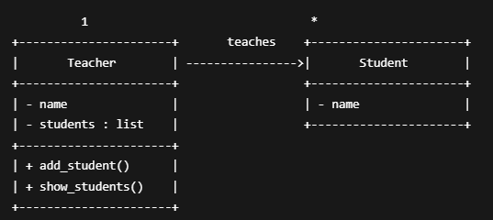
Many to Many Association

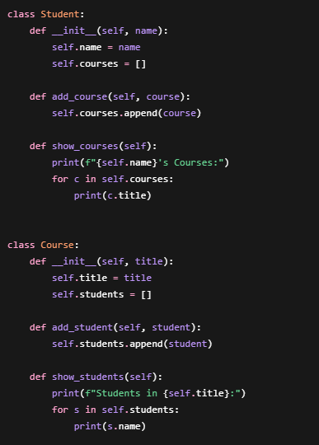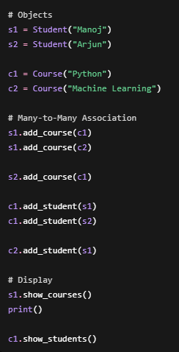

- From above example:
  - One student can enroll in many courses One course can have many students

- UML Diagram:

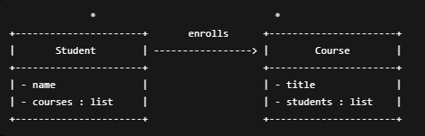

Composition
- Composition is where one class strongly owns another class. The child object is created and managed by the parent object. If the parent object is destroyed, the child object also typically gets destroyed.
- Composition is a strong type of association and it’s representing strong “has-a” Relationship.

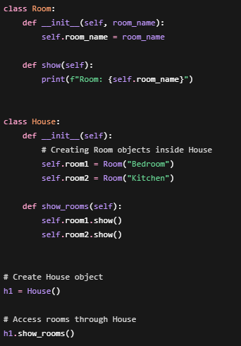

- From above code in House class
  - house is created rooms.
  - House are tightly coupled with rooms.
  - Rooms are the part of house.

- UML Diagram:

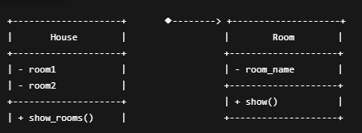
Aggregation

- Aggregation is where one object contains another object, but both can exist independently.
- Composition is a weak type of association and It’s representing a weak “has-a” Relationship.

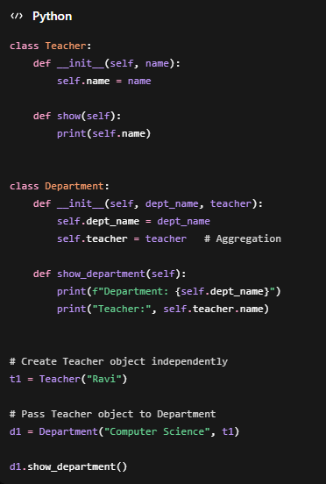

- From above Example:
  - Teacher can exist without Department
  - Relationship is weak therefore it is Aggregation

- UML Diagram:

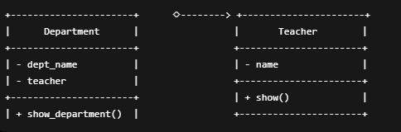
Inheritance

- Inheritance is an OOP concept where one class acquires the properties and methods of another class.
- It represents an “is-a” relationship between classes. The child class can reuse and extend the functionality of the parent class.

Types of Inheritance
- Single inheritance
- Multiple inheritance
- Multilevel inheritance
- Hierarchical Inheritance
- Hybrid inheritance.

Single Inheritance
Single Inheritance with Only Parent Constructor

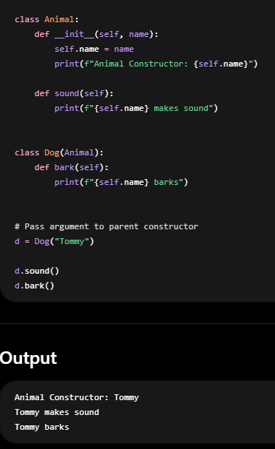
- From above example
  - child class does not define its own constructor, so it automatically uses the parent constructor.
  - Dog has no constructor so Python calls parent (Animal) constructor automatically

- UML Diagram:
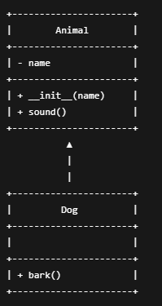

Single Inheritance
Single Inheritance with Parent and child Constructor

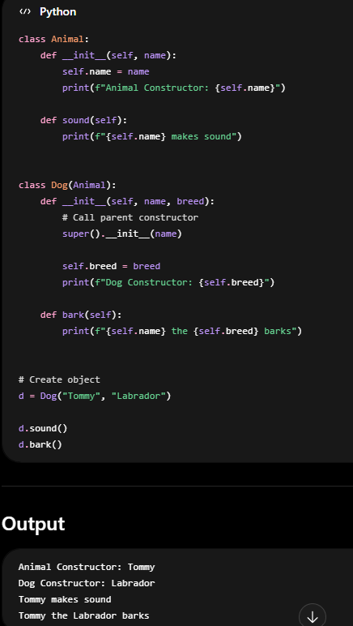

- From above example:
  - Here the child class has its own constructor, and parent class has its own constructor.
  - Child class Dog has constructor, Child constructor called parent constructor using super keyword.

- UML Diagram

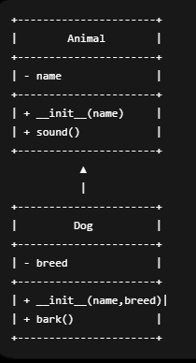
Multiple Inheritance
In multiple inheritance, one child class inherits from multiple parent classes.
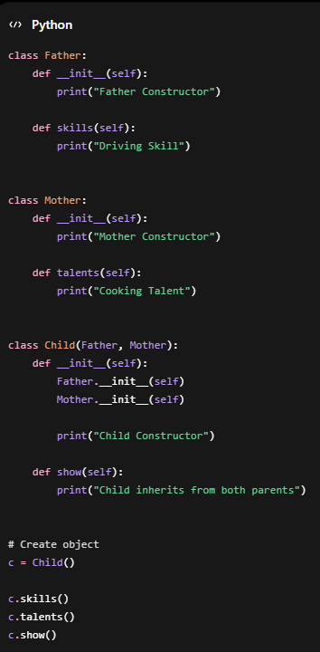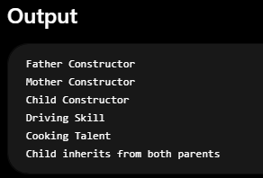

- UML Diagramm:

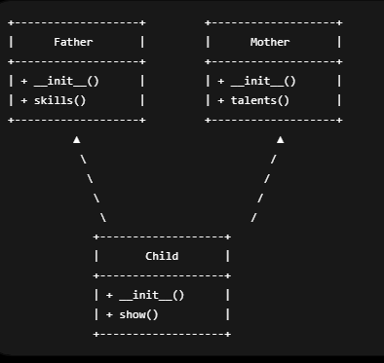

Multilevel inheritance
In multilevel inheritance, a child class inherits from another child class.
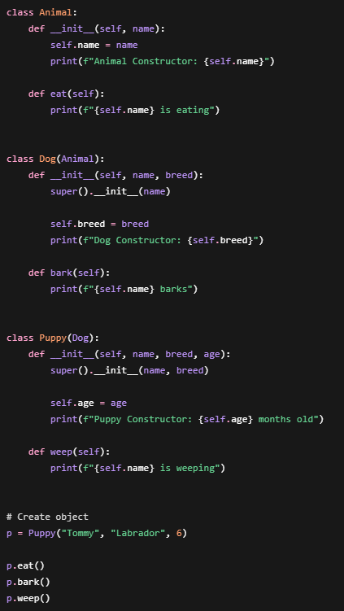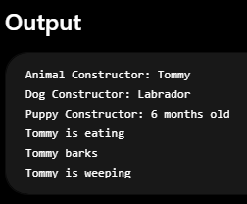

- UML Diagram:

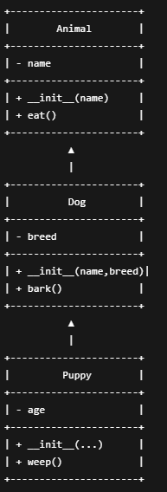

Hierarchical Inheritance
In hierarchical inheritance, multiple child classes inherit from the same parent class.

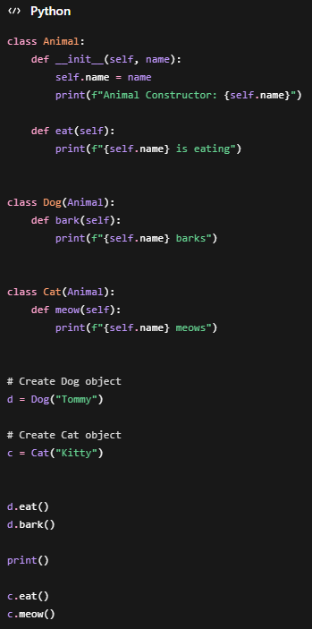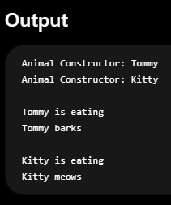

- UML Diagram:

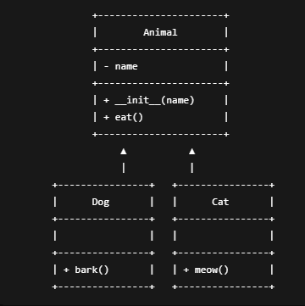

Hybrid inheritance
Hybrid inheritance is a combination of two or more inheritance types.
Commonly:
Hierarchical + Multiple inheritance together.

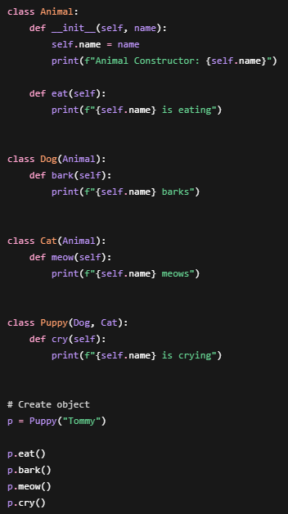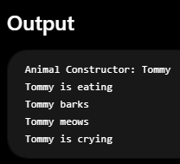

- UML Diagram:

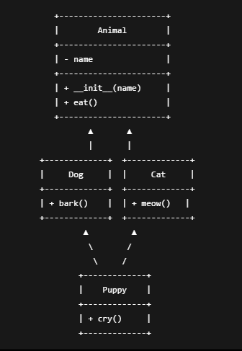

Diamond problem
Diamond problem occurs when a class inherits from two classes that share a common parent, creating ambiguity about which method or constructor should be used.
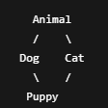
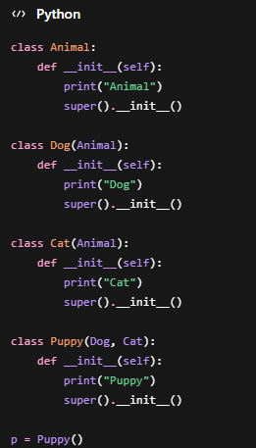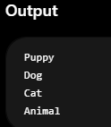

- From above Example:
  - Python Solves the Diamond Problem by using C3 Linearization (Method Resolution Order). (Hint: left to right class)
  - MRO (Method Resolution Order) is the sequence Python follows to locate methods and attributes in an inheritance hierarchy. Python uses the C3 Linearization algorithm to compute this order, ensuring a consistent and predictable search path, especially in multiple inheritance scenarios.
  - As shown below we can view the order in which class called using classname.mro().

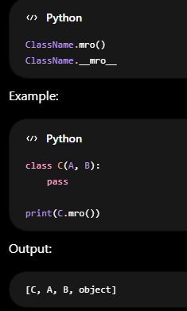
Abstract Class
- An Abstract Class is a class that serves as a blueprint for other classes.
  - It can contain abstract methods (methods without implementation).
  - It can also contain concrete methods (methods with implementation).
  - You cannot create an object of an abstract class directly.
  - Child classes must implement all abstract methods.
- In Python, abstract classes are provided by the built-in module abc (Abstract Base Classes).

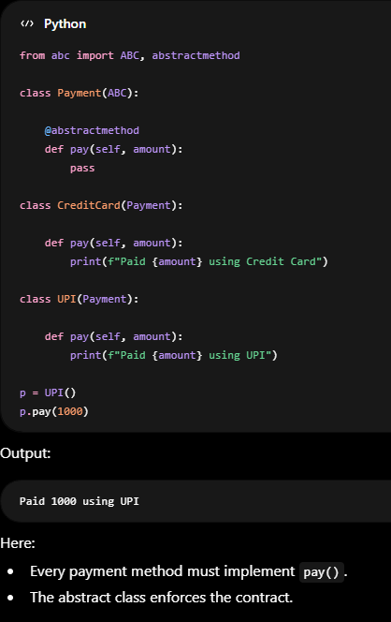

Interface
- Python does not have a separate interface keyword like Java or C#.
- Instead, Python typically uses Abstract Base Classes (ABC) → most common way to create interfaces.

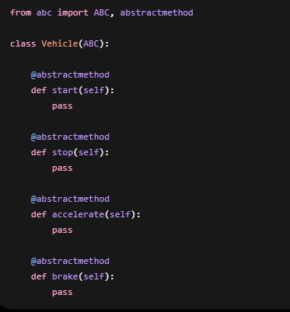
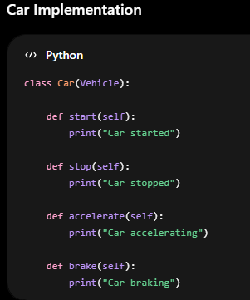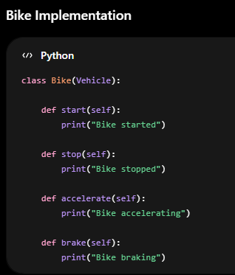

- From above Example
  - The Vehicle class serves as an interface, while Car and Bike are concrete classes that inherit from it. As a result, both classes must implement every abstract method specified by the Vehicle interface.

Method overriding
- Method Overriding occurs when a child class provides its own implementation of a method that already exists in the parent class.
- The child class overrides the parent's method.

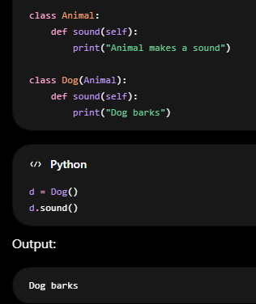
- Although sound () exists in Animal, Python uses the version in Dog.

Method overloading
- Python does not support compile-time method overloading; instead, it achieves similar functionality using default parameters, variable-length arguments (*args)

Duck Typing in Python

- Python does not care about the actual type of an object. It only cares whether the object has the required methods or attributes.
- The name comes from the famous saying: "If it walks like a duck and quacks like a duck, then it's a duck."
- In other words, Python focuses on behaviour, not type.

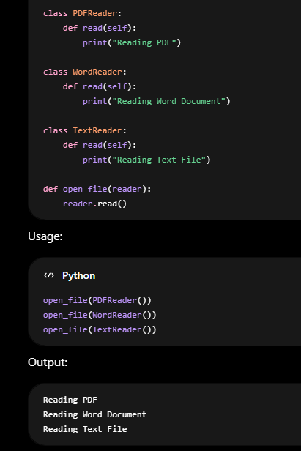
- open file() doesn't care what type of reader it gets. It only requires a read () method.

Polymorphism
- Polymorphism allows the same method or interface to behave differently for different objects.
- Python supports polymorphism. It is commonly achieved through:
  - Method overriding
  - Duck typing
  - Abstract classes/interfaces
  - Operator overloading (e.g., +, *)
- Python does not support traditional compile-time method overloading, but similar behaviour can be achieved using default arguments, *args, and **kwargs.

- In Python, methods are mainly of three types:
  - Instance Method
  - Class Method
  - Static Method

Instance Method

- An instance method works with object-specific data.
  - First parameter is self.
  - Can access and modify instance variables.
  - Requires an object to call it.

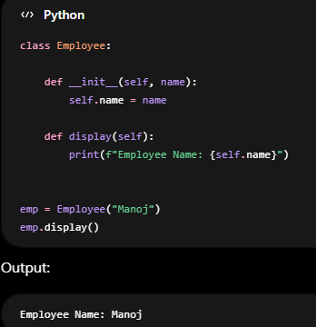

- NOTE:
  - “self” refers to current object.
  - If the method needs object data, then the first argument of method is self.

Class methods

- A class method works with class-level data.
  - Uses @classmethod.
  - First parameter is cls.
  - Can access class variables.
  - Can be called using either the class or an object.
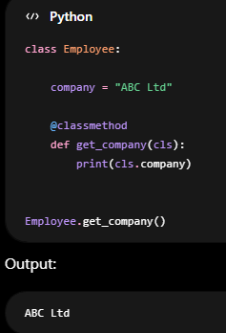

NOTE:
- cls refers to the class itself.
- If the method needs class data, then first argument of method is cls.
- Class methods are often used as alternative constructors (from_string(),
from_json(), factory methods).

Static method
- A static method is a regular function placed inside a class.
  - Uses @staticmethod.
  - No self.
  - No cls.
  - Cannot directly access instance or class data.
  - Used for utility/helper functions.

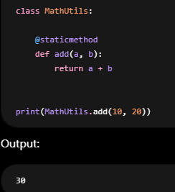
- NOTE:
  - Use a static method when the function logically belongs to the class but does not need self or cls.
  - static methods are used for utility functions that logically belong to the class but don't need access to either instance or class state.

Solid principles

- SOLID is a set of five object-oriented design principles that help make software easier to

- improves code maintainability.
- Reduces code coupling.
- Increases code reusability.
- Makes testing easier.
- Improves flexibility and scalability.
- Makes systems easier to extend and modify.

- Full form of SOLID as fallows
    - S — Single Responsibility Principle (SRP)
    - O— Open/Closed Principle (OCP)
    - L — Liskov Substitution Principle (LSP)
    - I — Interface Segregation Principle (ISP)
    - D — Dependency Inversion Principle (DIP)

Single Responsibility principle (SRP)
- A class should have only one responsibility or one reason to change.
- If a class is handling multiple jobs, a change in any of those jobs can force you to modify the class. SRP says each class should focus on a single concern.

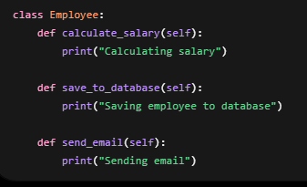
- Above class has three responsibilities:
  - Salary calculation
  - Database operations
  - Email notifications
- Reasons to change:
  - Salary calculation rules change
  - Database schema changes
  - Email format changes
- Conclusion: So, Above class violates SRP.
- Below is the example of class Employee with SRP:

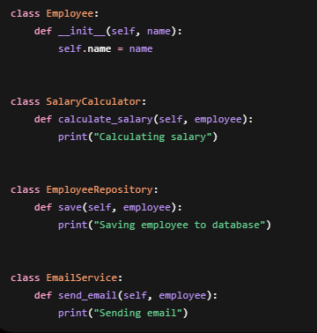

- Now, each class has one responsibility.
- Employee → stores employee data
- SalaryCalculator → salary logic
- EmployeeRepository → database operations
- EmailService → email operations

- Conclusion:
The Single Responsibility Principle (SRP) states that a class should have only one responsibility and therefore only one reason to change. For example, in an employee management system, salary calculation, database operations, and email notifications should be handled by separate classes rather than a single Employee class. This improves maintainability, readability, and testability.

Open/Closed Principle (OCP)

- Software entities (classes, functions, modules) should be open for extension but closed for modification.
- This means:
  - You should be able to add new functionality.
  - You should not need to change existing, working code.
- The goal is to avoid breaking existing code when new requirements arrive.
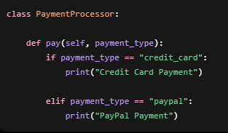
- For the above class if now business needs to add UPI. Then You must add if condition
for payement_type UPI.
- For the above class if now business needs to add Apple pay. Then again, you need to add the another if condition for payement_type Apple pay to existing class.
- So, for every new payement_type type requires changing existing code which violates OCP.
- Below is the code which will fallow OCP.
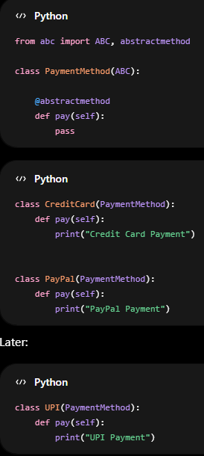
- PaymentMethod acts as an abstraction
  - It defines a common contract (pay () method) that all payment methods must implement.
  - Existing code depends on the abstraction, not on specific payment types.
- New payment methods can be added without modifying existing classes
- When UPI is introduced, we simply create a new class as shown below, no changes are required in CreditCard, PayPal, or PaymentMethod.
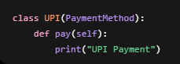
- Now, code remains closed for modification
- Credit Card and PayPal are already tested and working.
- We don't touch them when adding new payment methods, reducing the risk of bugs.
- The system is open for extension and we can easily add more payment methods such as:

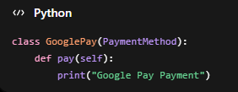

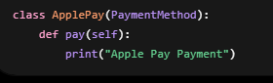
- The above design naturally supports growth.

- Polymorphism makes all payment methods interchangeable
- Any object that implements PaymentMethod can be used the same way:

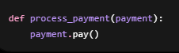
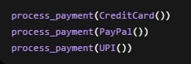
- Conclusion:
The Open/Closed Principle states that software entities should be open for extension but closed for modification. This means we should be able to add new functionality without changing existing code. For example, in a payment system, instead of modifying a PaymentProcessor class every time a new payment method is added, we create a common Payment interface and implement new payment classes such as CreditCard, PayPal, or UPI. This allows the system to grow while keeping existing code unchanged.

Liskov Substitution Principle (LSP)

- A child class should be able to replace its parent class without breaking the program's behaviour.
- If a piece of code expects a parent type, you should be able to pass any child type without breaking the behavior of code relies on.
- The child class should honor the contract of the parent class. The behaviour of overridden methods should remain compatible with what users of the parent class expect. It does not mean the implementation must be identical.
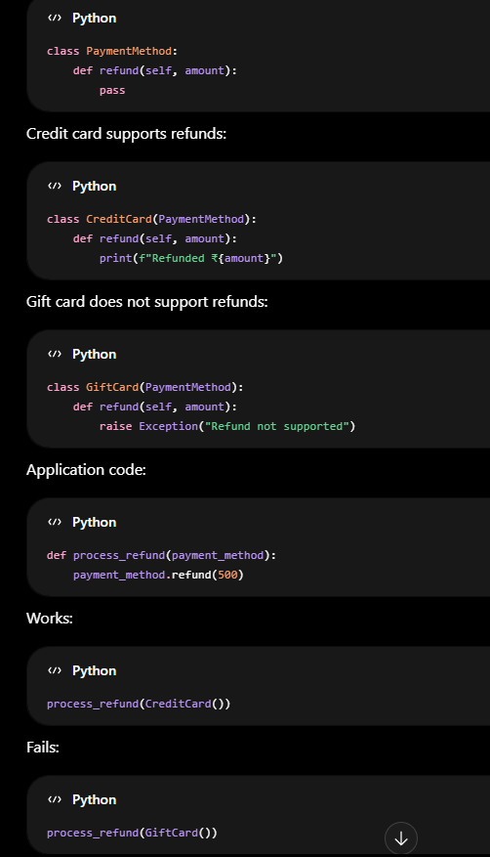
- The parent class promises, Every PaymentMethod supports refunds. But GiftCard breaks that promise. So LSP violated.
- In order to Fallow LSP its better to Separate payment and refund capabilities as shown below:
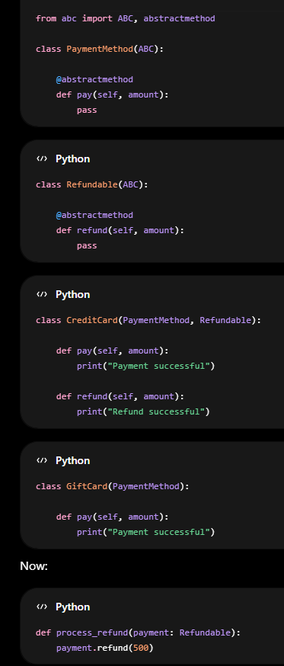
- Only refundable payment methods are passed to the method process_refund function.

- Conclusion:
In a banking system, if a BankAccount class provides a withdraw() method, then every subclass should support withdrawal. If FixedDepositAccount inherits from BankAccount but throws an exception when withdraw() is called, it violates the Liskov Substitution Principle because it cannot be used wherever a BankAccount is expected. A better design is to create a separate WithdrawableAccount abstraction and let only accounts that support withdrawals implement it. This ensures that subclasses can always substitute their parent classes safely.

Interface Segregation Principle (ISP)

- Clients should not be forced to depend on methods they do not use.
- Don't create one large interface with many unrelated methods.
- Create smaller, focused interfaces.
- A class should implement only the methods it actually needs.

- Suppose you're building a payment system. And create a single interface as shown below

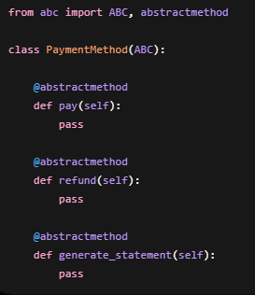

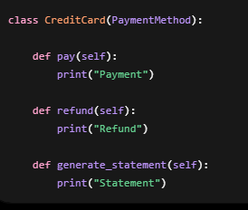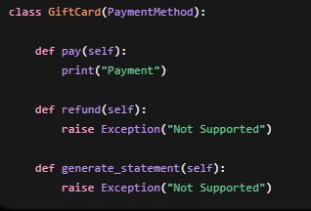

- CreditCard and GiftCard class is inherent from Paymentmethod and Credit Card supports everything pay and refund so those methods are redefined in CreditCard Class but Gift Card class does not support refunds or statements
- Gift Card class forced to implement methods like refund and generate_satement which doesn't need and will violate ISP.
- Below is the code which will fallow ISP.

- Split the interface into smaller interfaces as shown below:

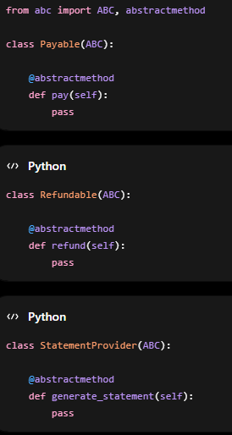

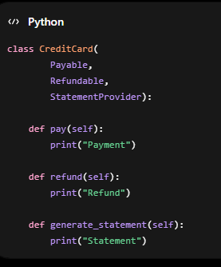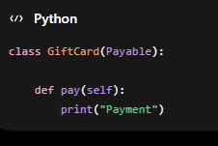
- Now Gift Card only implements what it needs and achieves ISP.

- Conclusion:
The Interface Segregation Principle states that clients should not be forced to depend on methods they do not use. Instead of creating one large interface, we should create multiple small and focused interfaces. For example, in a payment system, a Gift Card may only support payment, while a Credit Card supports payment, refund, and statements. Rather than forcing Gift Card to implement refund and statement methods, we create separate interfaces such as Payable, Refundable, and StatementProvider. This makes the design cleaner and more maintainable.

Dependency Inversion Principle (DIP)

- High-level modules should not depend on low-level modules. Both should depend on abstractions.

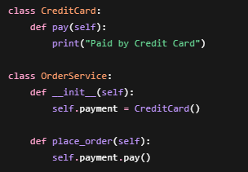
- The high-level business logic (OrderService) depends on a low-level implementation (CreditCard) which violates DIP.
- OrderService is tightly coupled to CreditCard.
- Tomorrow if business demands other payements methods like UPI, PayPal and Google pay you need to modify OrderServices. This will violate DIP.
- For the above code we can achieve DIP by creating Payment method interface and implement concrete payment methods like CreditCard, UPI, PayPal and Google Pay as shown below:

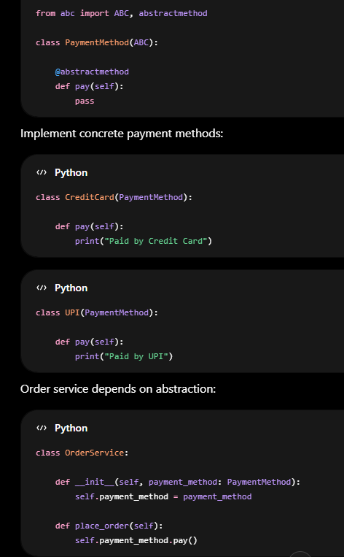
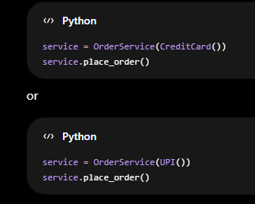
- In above code, If new payment methods will be added without changing OrderService. Now in above code both DIP and OCP achieved.
- Above is example where DIP helps achieve OCP.

Conclusion:
- The Dependency Inversion Principle states that high-level modules should not depend on low-level modules; both should depend on abstractions. For example, an OrderService should depend on a PaymentMethod interface rather than directly on CreditCard or UPI classes. This reduces coupling and makes the system easier to extend and maintain.

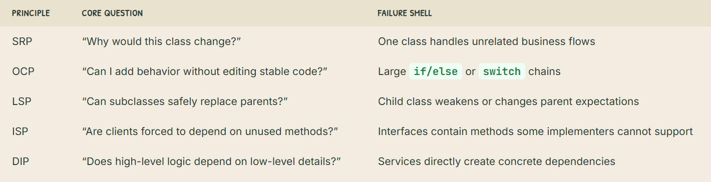

Design Patterns
- Design patterns are broadly divided into three categories:
  - Creational Design pattern
  - Behavioral Design pattern
  - Structural Design pattern

- Creational Design patterns will:
  - Manage object creation.
  - Hide or simplify the process of creating objects.
  - Make the system independent of how objects are instantiated.
  - Examples:
      - Simple factory, Factory method and Abstract Factory Design Pattern
      - Builder Design pattern
      - Prototype Design pattern
      - Singleton Design pattern

- Behavioral Design pattern will: -
  - define how objects interact and communicate
  - will define responsibilities and message flows.
  - Focus on interactions between objects.
  - Answers: "What happens when they talk?"
  - Examples:
      - Observer Design pattern
      - Command Design pattern
      - Chain of responsibility Design pattern
      - Iterator design pattern
      - Strategy Design pattern
      - Template Design pattern

- Structural Design pattern will:
    - Focus on how objects are connected/composed
    - Defines relationships between classes/objects.
    - Help make systems more flexible and maintainable.
    - Answers: "Who is connected to whom?"
    - Examples:
      - Adapter Design pattern
      - Decorator Design pattern
      - Bridge Design pattern
      - Composite Design pattern
      - Facade Design pattern
      - Proxy Design pattern
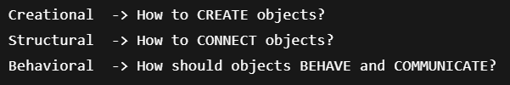

- Below is the simple analogy for Structural and behavioral design pattern

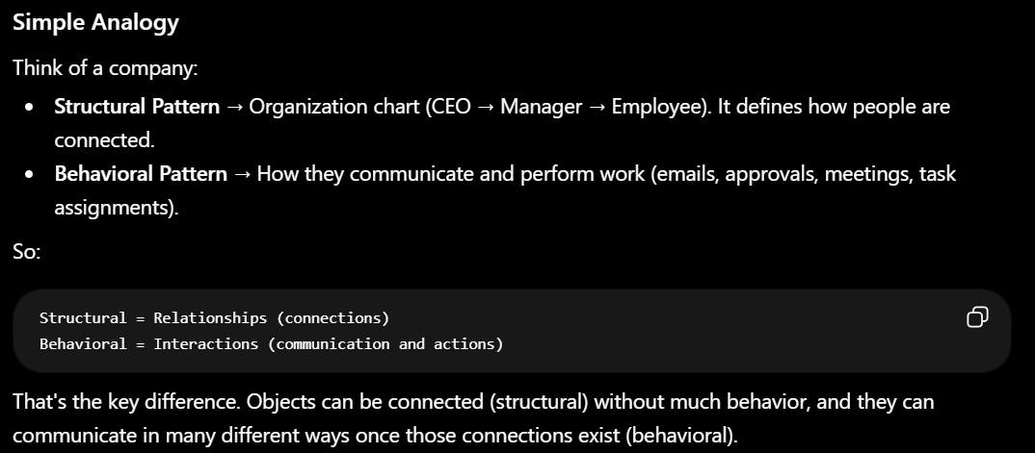

Q) without structural pattern behavioural pattern does not exist?
A) Conceptually, behavioral patterns need objects to exist and have relationships.
An object cannot communicate with another object unless there is some connection or
reference between them.

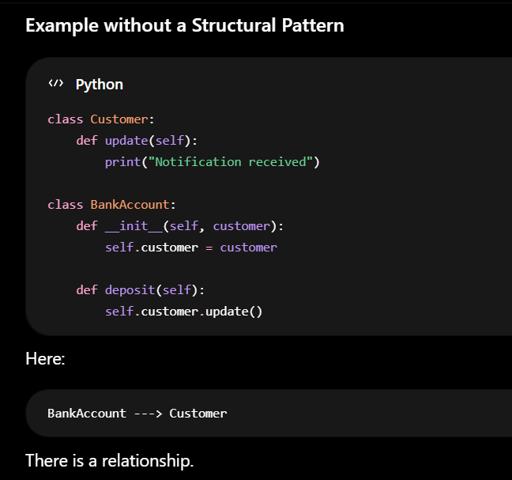

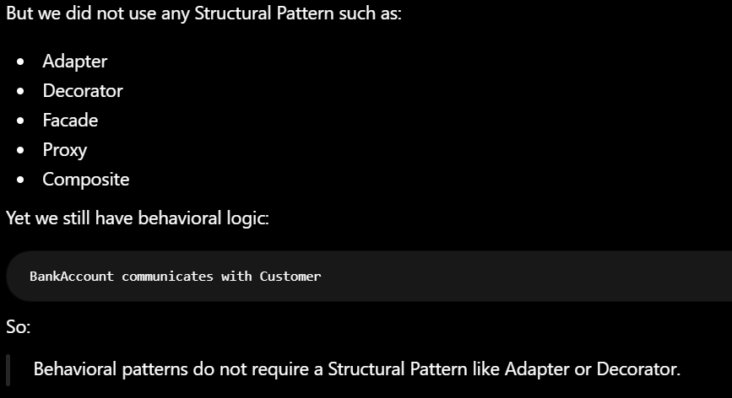

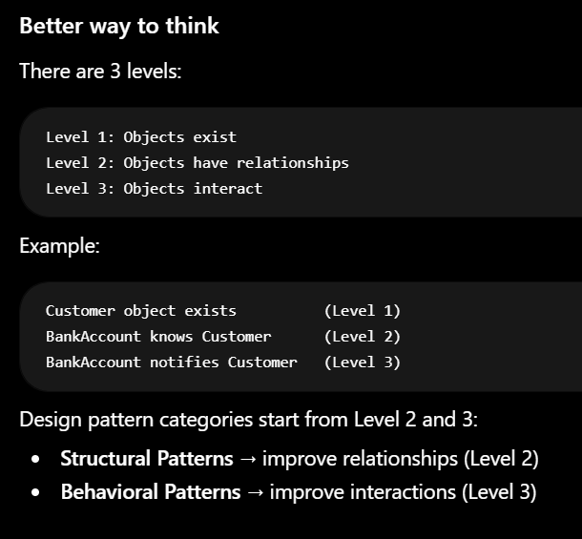

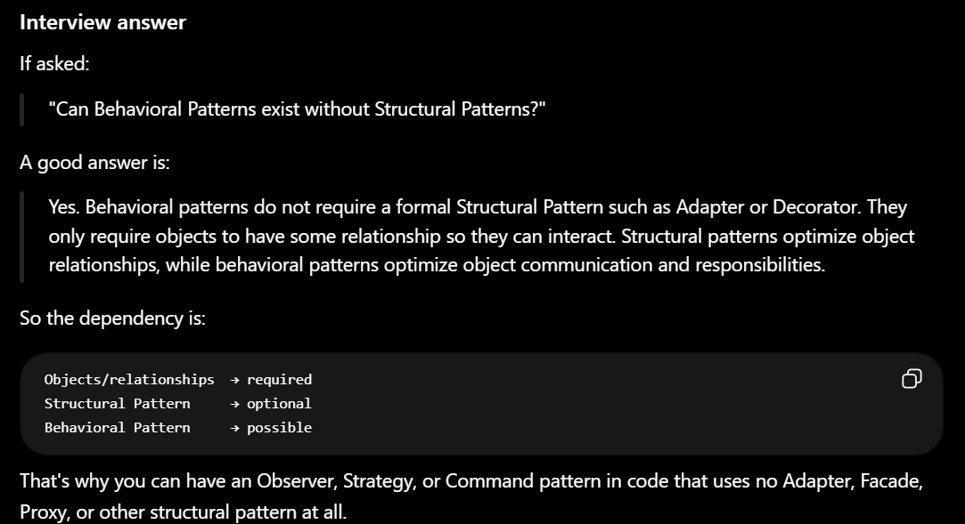

Creational Design Pattern (Prototype Design pattern)

  - Sometimes creating an object from scratch is:

    - Expensive (takes time/resources)
    - Complex (many configuration steps)
    - Repetitive (same setup repeated many times)

  - Instead of creating a new object every time, you:

    - Create one fully configured object.
    - Clone (copy) it.
    - Change only the fields that need to be different.

